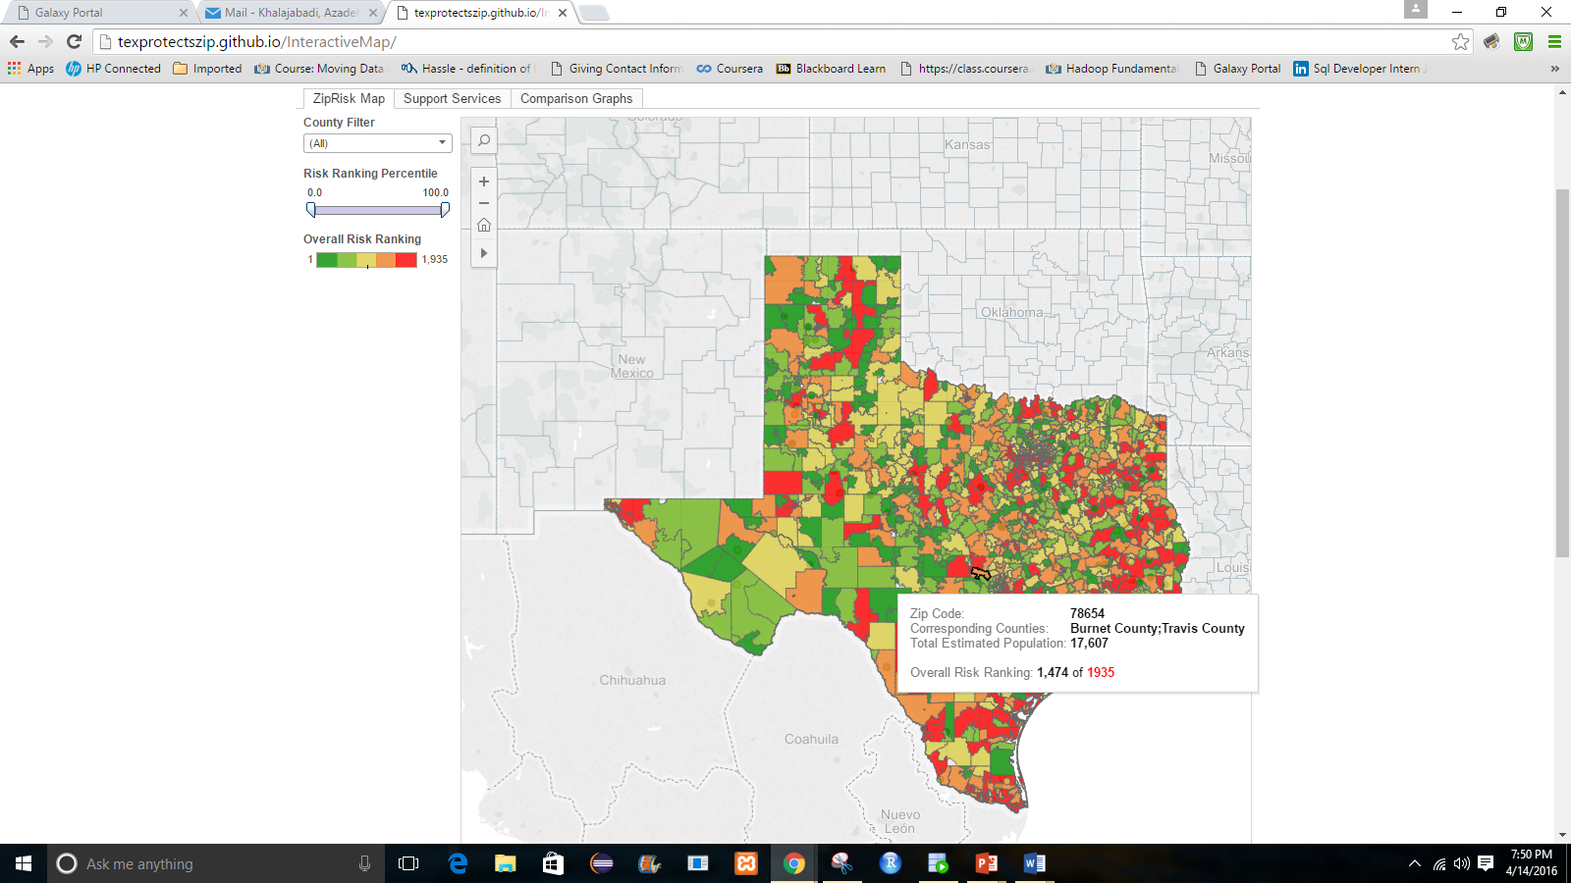

Use this toolbar to help with navigating the map. Click the triangle then the cross to enable pan and select.

Use these tabs to navigate between the *Zip*Risk Map, Services Map, and Graphs.

Move the slider to filter zip codes by their Risk Ranking percentile. The slider can be moved from both sides.

Type in a county or use the drop down menu to select and filter by county.

Hover over a zip code to show the tooltip containing: Corresponding counties, Total estimated population, and Overall Risk Ranking out of 1935.

This map shows all services available in Dallas county. Data can be filtered by zip code or resources type. Data may not be available in all zip codes

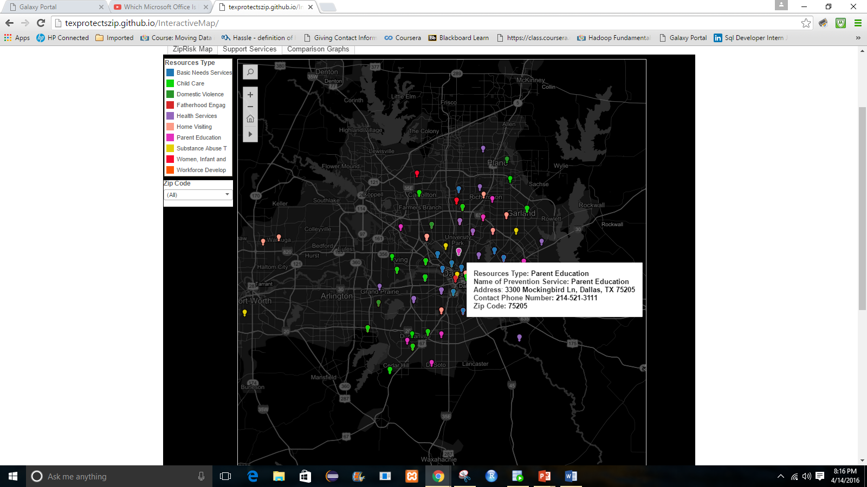

Hover over each pin to see the information as shown here. To get driving direction click on the pin and then click on Map it

Here, you can filter by zip code by selecting the zip code from drop down menu

Here, you can filter by resources type by clicking on the name of each resource

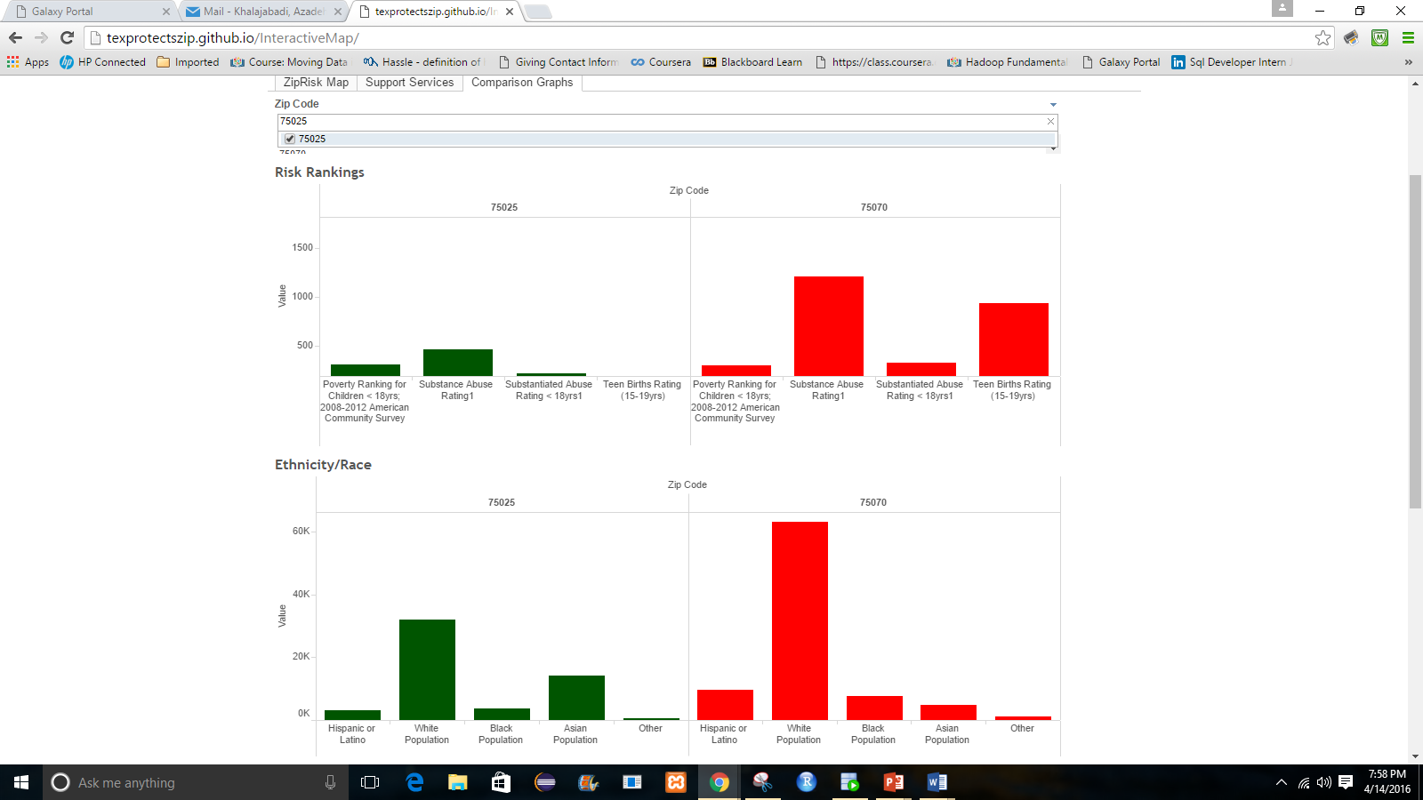

Comparison of zip codes by Ethnicity/Race. Can support multiple zip codes.

Comparison of zip codes by Risk Rankings. Can support multiple zip codes.

First, type in the zip code(s) you want to graph.